Command to execute the test is -> py.test compareApi_test.py --browser chrome



Above command can be modified to run all test on Firefox or Internet explorer. The code to handle this scenario is already developed in the framework.

Currently framework accepts inputs through testdata.csv file stored at the start of test framework:

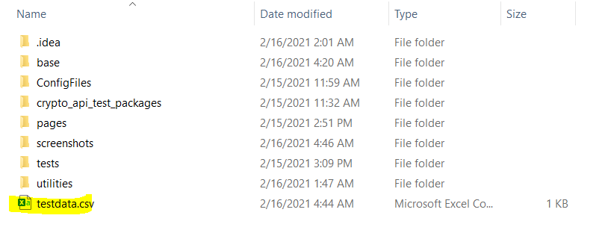

This file contains two parameters: Instrument and interval. For executing more variety of test, we can add different inputs here.

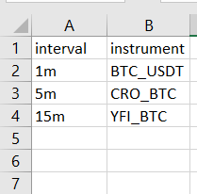

Inside code our test function (test_apidata) executes for each entry in testdata.csv

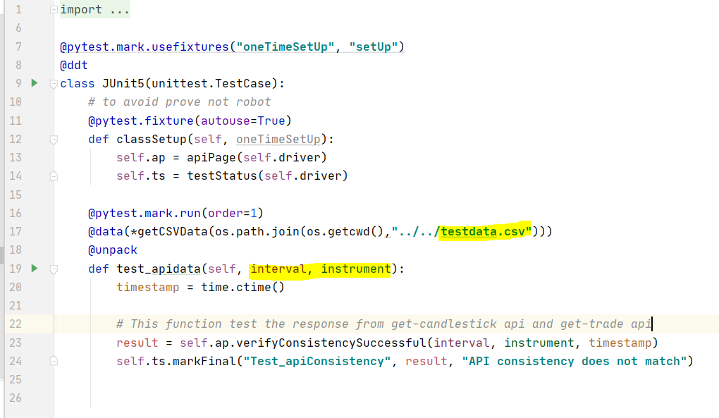

Framework uses modular approach to increase the reusability of code.

The base directory contains all basic functionalities related to webpage.

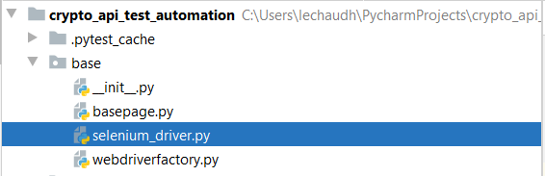

The Page directory contains functions very specific to particular page/Api 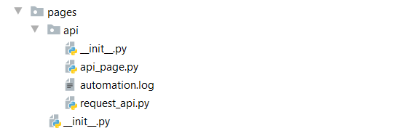

All screenshots taken on failure of test are kept in separate folder.

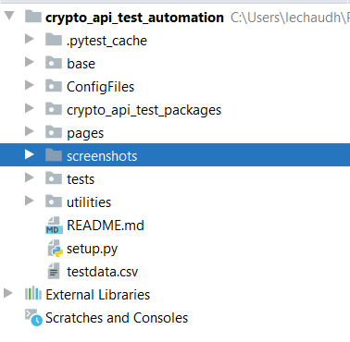

Test folder contains all main test function and its directory structure is same as Page directory structure. Execution of test starts in test folder.

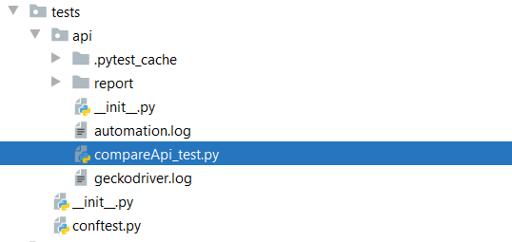

Utility contains all framework related miscellaneous task e.g. log file management, test data management, reading input from csv etc.

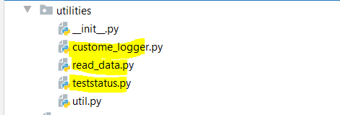

Details on out-put file are mentioned in [Sample test run output Crypto.docx](https://github.com/leena2208/crypto/blob/main/Sample%20test%20run%20output%20Crypto.docx) file.